Question 1. Studying double-speed. During the pandemic, many professors distributed recordings of their previous lectures so that students could learn at their own pace. When this happens, some students reported preferring to watch the lecture at faster than original speeds, but it is unknown how this might affect how effective learning is.

Murphy et al. (2021) conducted a study in which participants watched the same lecture video at different speeds. A group of 110 students were recruited and randomly assigned to either watch the video at 1x speed (Group A) or to watch the video at 2x speed (Group B). Group B then watched the video a second time. After watching, both groups took a test based on multiple-choice questions to measure their comprehension of the video content. The test was graded out of 100 points. (5 pts each; 35 points total)

1. What is the independent variable in this study? What construct is it intended to capture?
2. What is the dependent variable in this study? What construct is intended to capture?
3. What is the purpose of the experimental design choice to have the participants in Group B watch the video twice?
4. Here are some hypothetical data that might have come from the study. Write out a results statement for the descriptive statistics in APA format. Include the direction of the difference between groups (but the inferential statistics are below).

|  |  |  |  |
| --- | --- | --- | --- |
| Condition | Mean | SD | SE |
| Group A | 71.51 | 15.79 | 2.13 |
| Group B | 85.05 | 14.42 | 1.94 |

1. Running the analysis in R produced the following output. Format it in APA style how you would support the results statement from (d).

|  |
| --- |
| **R Output**  data:  Test_score by Condition  t = 2.8528571, df = 108, p-value = 0.0048471  alternative hypothesis: true difference in means is not equal to 0  95 percent confidence interval:    7.780764 19.319324  sample estimates:  mean in group 1x: 71.51234723  mean in group 2x: 85.04917491 |
|
|
|
|

1. Although the main hypothesis was about video playback speed, there is an alternate way to explain the findings. Give the alternate hypothesis. Then give a statement defending the finding and arguing in favor of a conclusion based on playback speed and comprehension.
2. After reading this paper, students in a study group think it might be interesting to try the effect themselves. They decide to all watch their lecture videos at double speed and then interview each other to evaluate how well they learned. Describe three flaws in this informal research approach that make it unsuitable for testing the experiment hypothesis.

Question 2. Fill in the blank with the appropriate term (3 pts each; 30 total).

|  |  |
| --- | --- |
| ____________________________ | An error where the experimenter incorrectly claims that the independent variable affected the dependent variable when there was no reliable effect. |
| ____________________________ | A control technique for anything that cannot be kept constant in the experiment, keeping this factor from being confounded with the independent variable. |
| ____________________________ | The section of an APA-style research report where you present the main findings of the study, including the results of the statistical analyses. |
| ____________________________ | The term for the procedure when experimenters do not inform the participants about the hypothesis or the other condition in a two-group independent sample study. |
| ____________________________ | A positive effect of a simulated treatment that lacks any active ingredient other than participants’ expectations about the treatment |
| ____________________________ | The name of the department that reviews formal research for compliance with principles of research ethics |
| ____________________________ | The process of participants indicating that their participation in research is entirely voluntary and with knowledge of all the risks and potential benefits of the study |
| ____________________________ | When participants’ responses across multiple conditions are affected by the order of conditions to which they were exposed. |
| ____________________________ | When an experiment is designed carefully so that there are no confounds that would lead to alternate explanations, we say the experiment has this |
| ____________________________ | The degree to which the measure used in the experiment visible relates to the underlying construct meant to be measured. |

Question 3. Blaming the victim. In Dawtry et al. (2020), the researchers explored a phenomenon in which participants tended to judge crime victims more harshly when they saw a more emotional presentation of the crime. Participants were exposed to a victimization scenario that was presented either as a relatively dry third-person written text vignette (description) or watching an engaging video taken of the crime as it actually took place. They were then asked to rate the character of the victim of the crime on the following scale:

“How negative-to-positive would you evaluate the robbery/assault victim as a person”;  
0 = very negatively, 10 = very positively

1. What is the independent variable in this study? How does it connect to the construct it is intended to capture via the original hypothesis?
2. What is the dependent variable in this study?
3. The description above presents the design as based on a single scenario. We might prefer to collect multiple data points from each participant to better test the experimental hypothesis. Name 3 extraneous variable related to the experimental stimuli that would have to be considered and controlled as best as possible.
4. Describe a participant-based extraneous variable (something that differs across people) that might influence the DV in this design. If participants were randomly assigned to conditions, would this potentially confound the experiment? What might go wrong?
5. In preparing stimuli for this study, we might employ a measure used as a “manipulation check” for crime videos and the associated text descriptions of the crime. Given the original hypothesis motivating this experiment, what would we measure about these potential new stimuli and why?
6. The authors found a difference in the ratings given to the crime victims in the expected direction with the victims seen in the videos rated more negatively. They interpreted their results as related to a “just-world theory” in which participants believe the world is a fair place where people generally get what they deserve and therefore that victims bear some blame for what happens to them. However, what confound is present across the two conditions used in this study? Can you give an alternate explanation for the results?
7. Participants in this study would need to be informed in advance about the protocol. What risks would need to be explained? Why would it be important to assure that the privacy of the participants would be maintained?

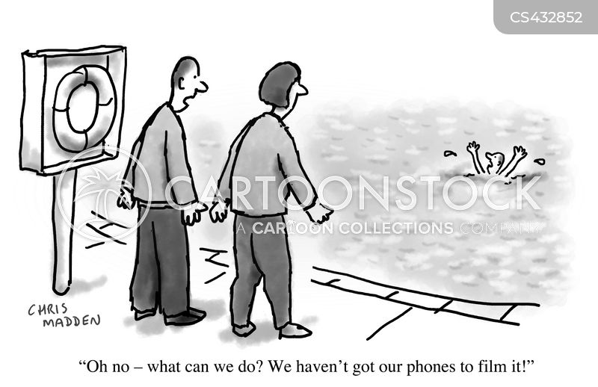

*Paper for reference*

Dawtry, R. J., Callan, M. J., Harvey, A. J., & Gheorghiu, A. I. (2020). Victims, vignettes, and videos: meta-analytic and experimental evidence that emotional impact enhances the derogation of innocent victims. *Personality and Social Psychology Review*, *24*(3), 233-259.